ESP32 CONFIGURATION STEPS
1. IDE Arduino installation:
- Download and install IDE Arduino from official site: https://www.arduino.cc/en/software.

2. Adding ESP32 Support in the Arduino IDE:
- Open the Arduino IDE and go to File > Preferences.
- In the "Additional Boards Manager URLs" section, add the following URL for ESP32: https://dl.espressif.com/dl/package_esp32_index.json
- Go to Tools > Board > Boards Manager....
- Search for "ESP32" and install "esp32 by Espressif Systems".

2.1 Configure the IDE for ESP-EYE:
- Connect the ESP-EYE board to the computer using a USB cable.
- Go to Tools and configure the following:
  - Board: Select ESP32 Wrover Module (it is compatible with ESP-EYE as it uses the same chip).
  - Flash Frequency: 40MHz.
  - Partition Scheme: Select Huge APP (3MB No OTA) (required for applications that use a lot of memory).
  - Port: Select the COM port assigned to the ESP-EYE board.
  - Upload Speed: Set to 115200 (standard for ESP32).

3. Selecting the ESP32 Board:
- Go to Tools > Board and select ESP32 Dev Module (or a compatible ESP32 board).
- Go to Tools > Port and select the COM port to which the ESP-EYE is connected.

4. Connecting and Configuring the ESP-EYE:
- Connect your ESP-EYE board to the PC via USB cable.
- If the port doesn't appear, try disconnecting and reconnecting the cable, or update the USB drivers for ESP32.

5. Checking the Serial Connection:
- Open the Serial Monitor in the Arduino IDE (Tools > Serial Monitor).
- Ensure that the baud rate of the serial monitor is set to 115200 baud.
- Upload a simple sketch like the following to verify that the ESP32 is working properly:
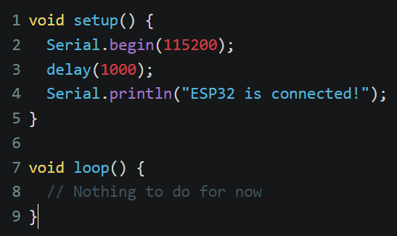

- If the serial monitor displays the message "ESP32 is connected!", it means the communication was successfully established.

6. Uploading the Sketch to ESP-EYE:
- Once the connection is verified, you can upload your code via Tools > Upload.
- After the upload is complete, the ESP32 will start executing the uploaded code.

ISSUES ENCOUNTERED 05/12/2024:
It was not detecting the COM port. It was necessary to update the CP210 driver. The connection was successfully established, and the board connected to the home Wi-Fi. I’m attaching the base code for Wi-Fi connection (testConn.c).

